Karan Vora (kv2154)
Introduction to High-Performance Machine Learning (ECE-GY 9143) Assignment-1

C1 Results

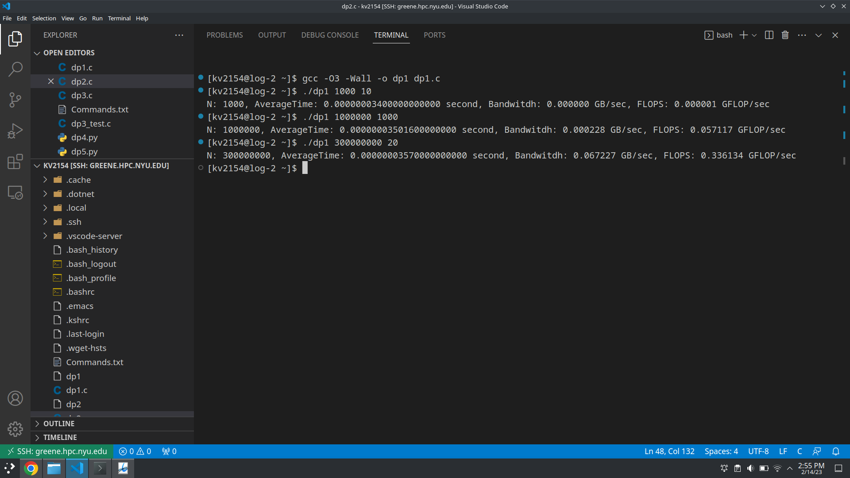

=========================================================================

C2 Results

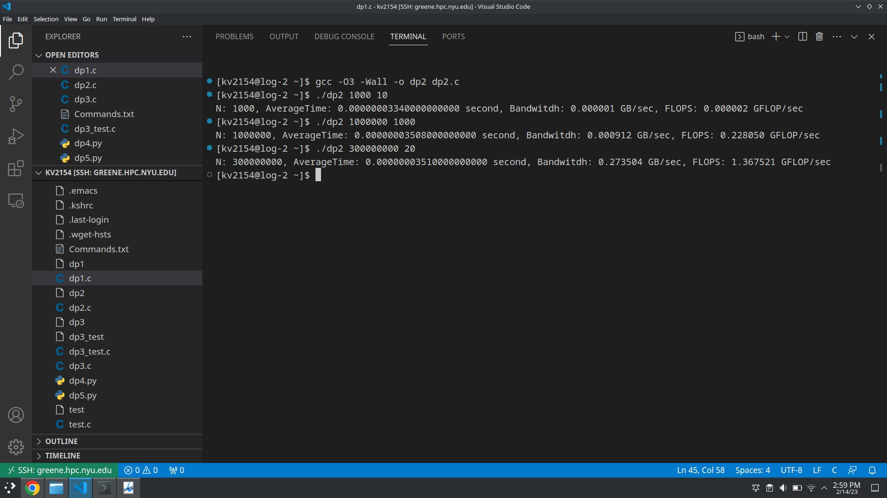

=========================================================================

C3 Result

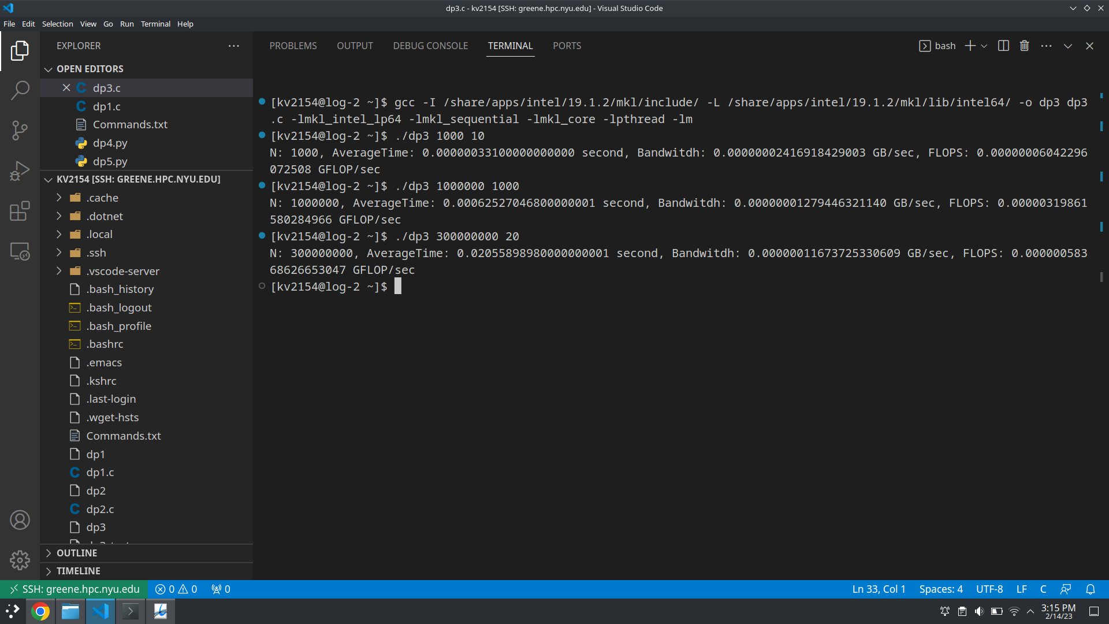

=========================================================================

C4 Result

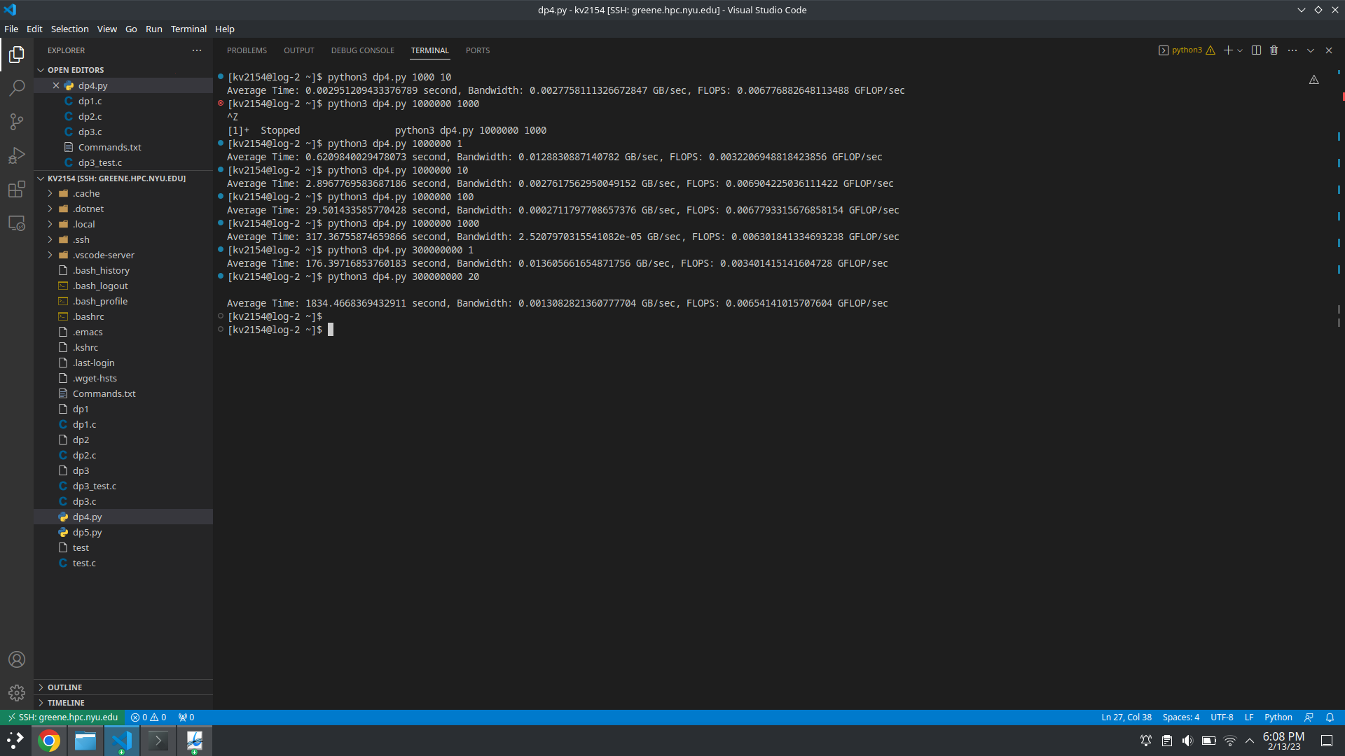

=========================================================================

C5 Result

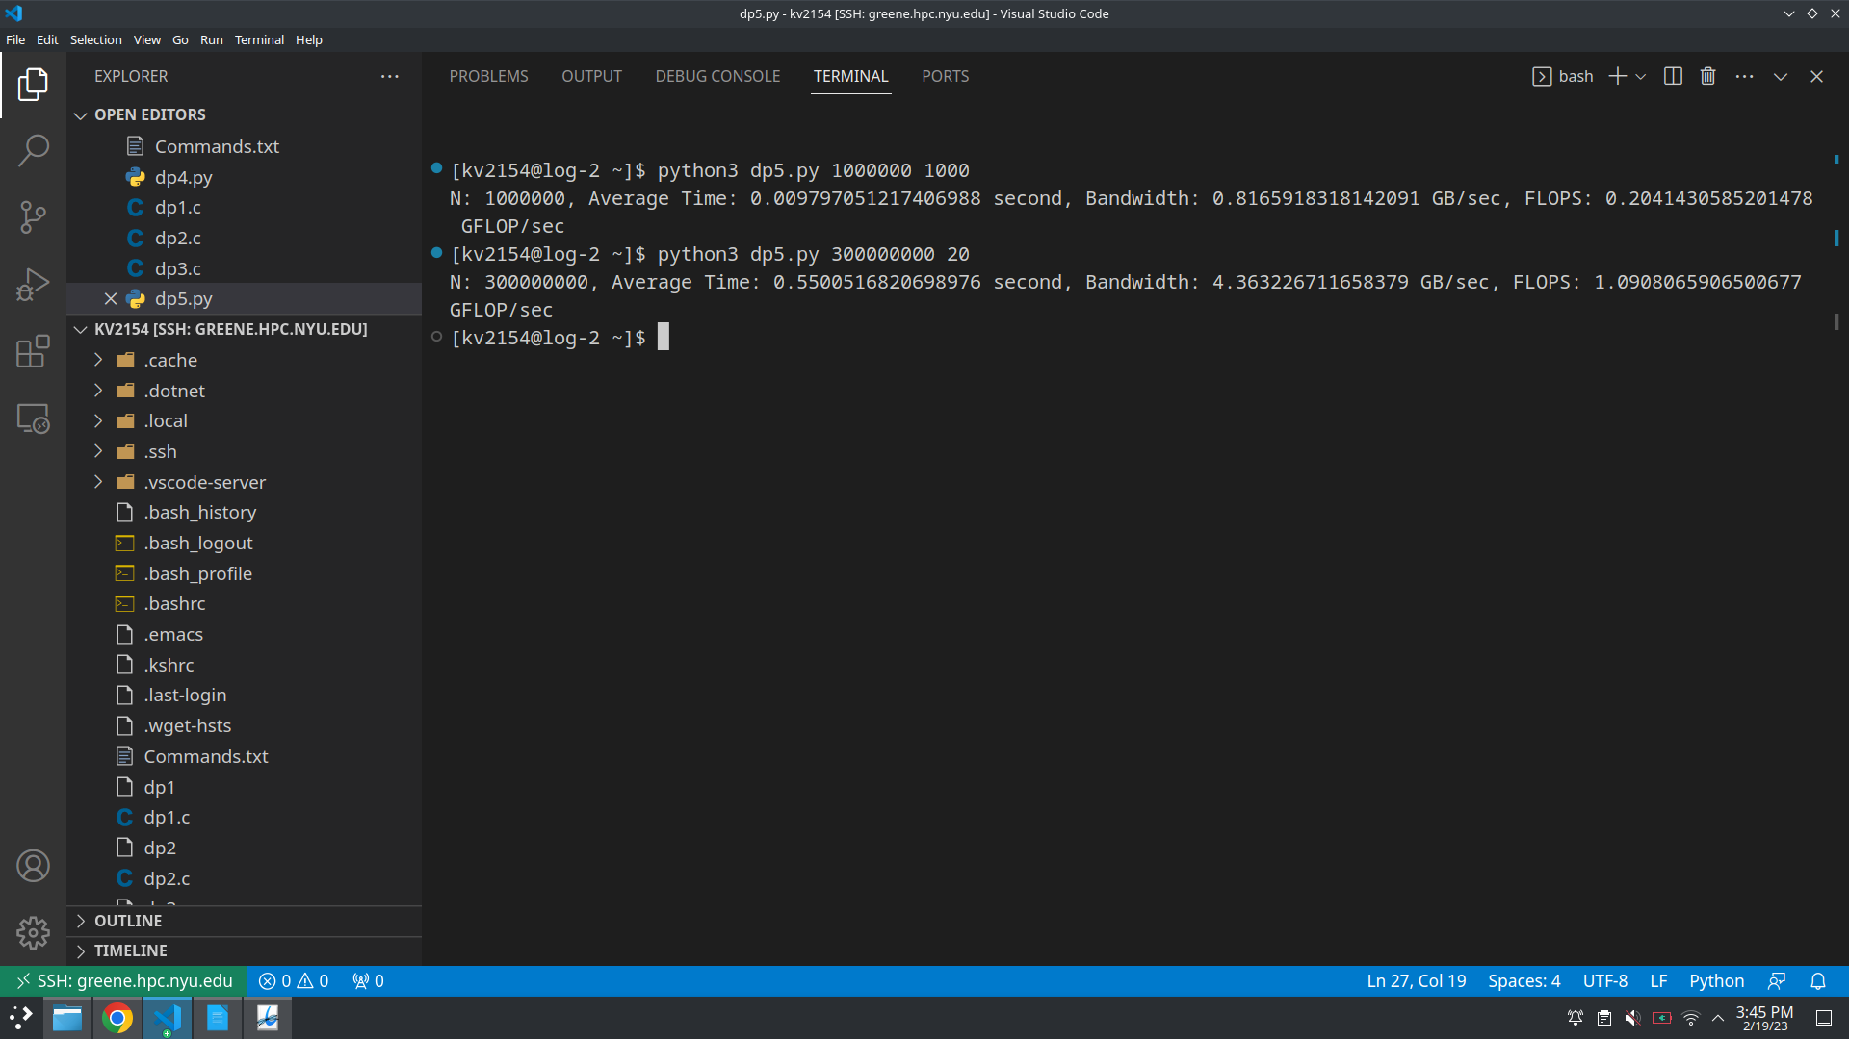

=========================================================================

Q1:

If only 2nd Half of the dataset, The computed average will not be the true representation of computed dataset. Mean is a statistical summary of the whole dataset so when only a part of it is used, It wont reflect the true tendency of the dataset.

In addition, using only the second half of the measurements can lead to a biased estimate of the mean. This is because the portion of the data that is used may be systematically different from the entire dataset in some way. For example, the second half of the measurements may be systematically higher or lower than the first half. This would result in a biased estimate of the mean.
=========================================================================
Q2:
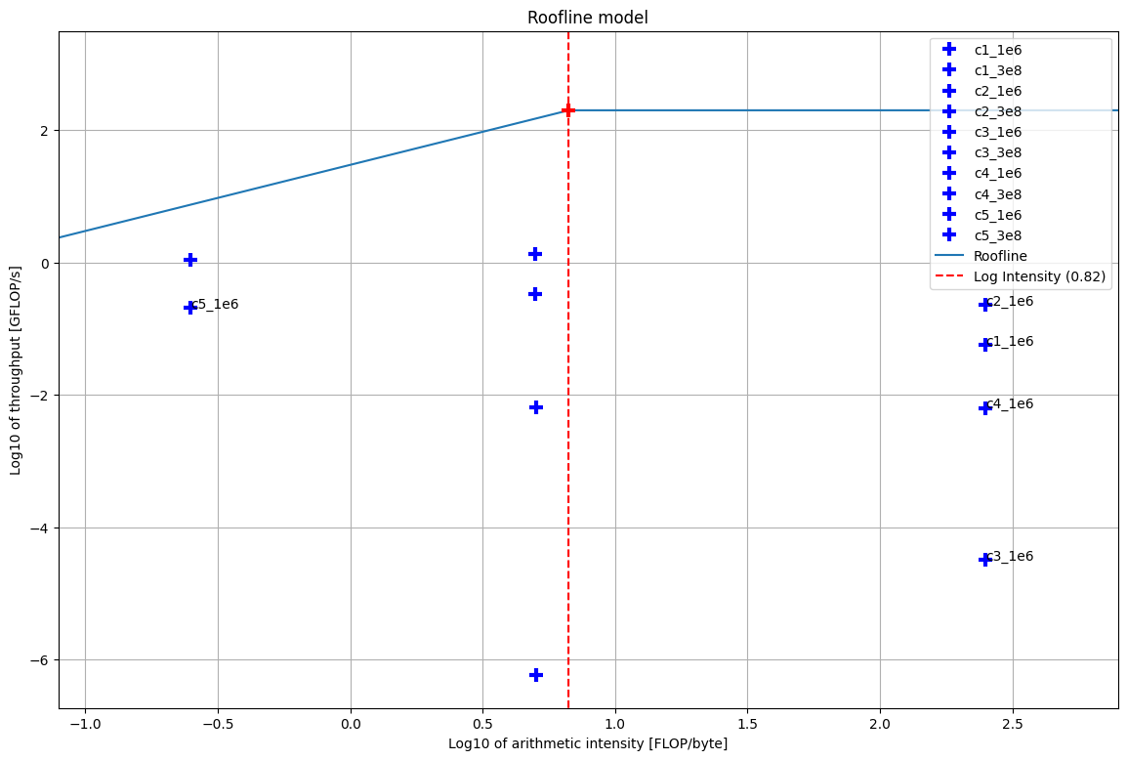

=========================================================================
Q3:
At N = 300000000, the average time per iteration for dp1 is 35.7 nanoseconds at bandwidth of 0.067227 GB/sec and average FLOPS is 0.336134 GFLOP/sec.
At N = 300000000, the average time per iteration for dp2 is 35.1 nanoseconds at bandwidth of 0.273504 GB/sec and average FLOPS is 1.367521 GFLOP/sec.
At N = 300000000, the average time per iteration for dp3 is 0.02055 nanoseconds at bandwidth of 0.00000011673 GB/sec and average FLOPS is 0.0000005836 GFLOP/sec.
From above mentioned data we can extrapolate that though execution time time for dp1 and dp2 is similar, the flops performance and memory access is far higher for dp1 vs dp2. Meaning the arithmetic intensity for dp2 is higher than that of dp1. dp3 has the lowest performance for the same size of array, it takes the most time to perform the dot product thus the arithmetic intensity of dp3 is the lowest.
=========================================================================
Q5:
At N = 1000, the average time per iteration for dp1 is 34 nanoseconds at bandwidth of 0.000002 GB/sec and average FLOPS is 0.000001 GFLOP/sec.
At N = 1000000, the average time per iteration for dp1 is 35.01 nanoseconds at bandwidth of 0.000228 GB/sec and average FLOPS is 0.057117 GFLOP/sec.
At N = 300000000, the average time per iteration for dp1 is 35.7 nanoseconds at bandwidth of 0.067227 GB/sec and average FLOPS is 0.336134 GFLOP/sec.
At N = 1000, the average time per iteration for dp5 is 3.175 microseconds at bandwidth of 2.58 GB/sec and average FLOPS is 6.2998 GFLOP/sec.
At N = 1000000, the average time per iteration for dp5 is 0.004 seconds at bandwidth of 2.0013 GB/sec and average FLOPS is 500.323 GFLOP/sec.
At N = 300000000, the average time per iteration for dp1 is 0.46 seconds at bandwidth of 5.218319 GB/sec and average FLOPS is 26.09 GFLOP/sec.
As per above mentioned observations we can clearly see that dp1 executes much faster than dp5 even though the GLOPS performance is higher indicating that dp1 is much more efficient and the arithmetic intensity of dp1 is higher because it requires much less GFLOPS to finish the same task with same size of data. dp1 is also much more memory efficient as compared to dp1 requiring much less of resources to execute the same process.

